Potential Newsletter Material
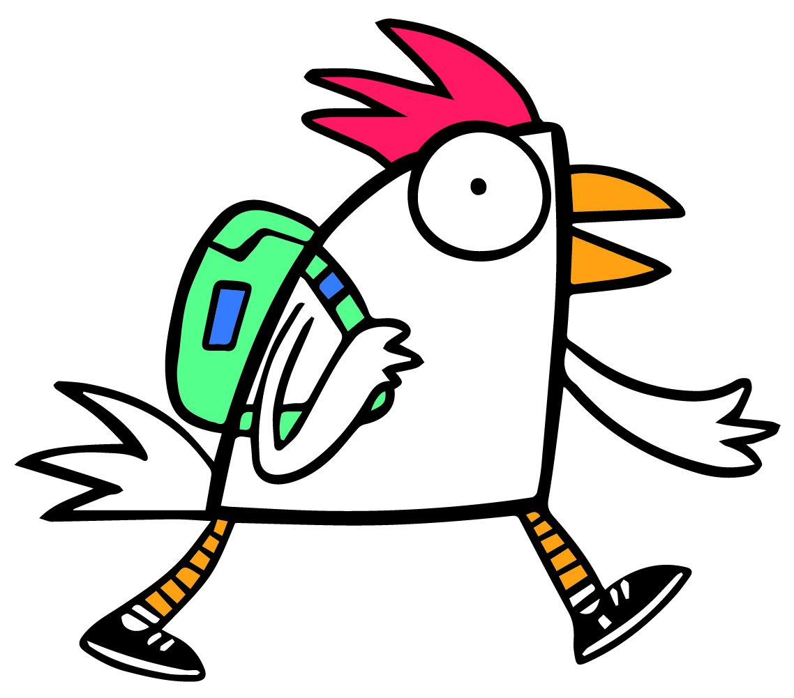
Introducing program
[Name of your school] is running a trial of Free Range Kids - a program that encourages children to walk to and from school. They earn points each time they walk, and when their class reaches a certain number of points, their class earns a reward.
The program officially starts [date]. If you child’s class is participating, they will bring home an Information Sheet that will help you decide if you wish your child to participate. It will explain that your child does not have to walk all the way, just as far as they are able. We are establishing a number of drop-off and pick-up points.
The Information Sheet will also give you some very useful hints on getting your child ready to walk.
Week that information sheet goes home
This week your child will bring home an Information Sheet about the Free Range Kids. It outlines what your child stands to gain by participating, and how you can prepare your child for walking. It also contains a map showing where the official drop-off points are.
Start of program
This week is the start of Free Range Kids. Your child does not have to walk all the way – only as far as they are capable or from one of the drop-off points. Each time your child walks to or from school they earn a point, and when their class reaches a particular goal, the entire class gets a reward. This is a class challenge with the entire class working towards the reward.
Wanted: Free Range PARENTS
We are looking for parents whose children have been free-range for some time. We would love to share your stories about how you made the decision to let your child go free-range, how you prepared your child, and the advantages you see for your child (and yourself) in allowing them to free-range.
During the first six weeks of program
Publish the best of the children’s Adventure drawings and stories.

One of the hidden benefits of Free-Range Kids?
John Adams from Britain has suggested that very soon, we will no longer have a generation that remembers walking to school.
What is the significance of this? How important are those lingering, sensory experiences that many of us can remember from our childhood -- playing with mud puddles, kicking through piles of autumn leaves, and chatting with buddies along the way to school?
One retired British teacher has written about the loss of lived experiences of his students:
I found it increasingly difficult to stimulate children’s writing and artwork because there was so little in the way of stored experience for them to use... If I wanted children to write about walking in the rain I had to suggest just about everything because so few of them had walked in the rain... Not one, not one of them had the chance to feel raindrops running down their backs. Had any of them walked in the morning fog? Not one. Had they had the chance to walk into the teeth of a howling wind? Had they felt the full force of a hail-storm? Of course not.
Friendlier Neighbourhoods – another benefit of Free-Range Kids
Community life is constructed out of the informal and accidental interactions people have while walking the dog, shopping, or walking to school. The more people there are in public space, the more interesting the space becomes and the greater the opportunities for a rich community life.

